**BIT302 SOFTWARE ENGINEERING**

**Assignment 1**

HELP COVID-19 Testing Information System (CTIS) Website – Project Plan



**Team Leader**

I Made Siva Aditya Surya / E1800176

[mdsivaaditya@gmail.com](mailto:mdsivaaditya@gmail.com)

**Member**

Ida Bagus Gede Awidya Andika / E1800182

[awidyaandika@gmail.com](mailto:awidyaandika@gmail.com)

2021

Table of Contents

**Table of Contents** i

**1.** **Overview** 1

**1.1.** **Project Background and Motivation** 1

**1.2.** **Project Customer/User** 2

**1.3.** **Project Deliverables** 2

**1.4.** **Project Estimate Cost** 2

**1.5.** **Project Duration** 3

**2.** **Project Aims** 3

**3.** **Project Objectives** 3

**4.** **Project Scope** 4

**5.** **Project Schedule** 5

**5.1.** **Work Breakdown Structure** 5

**5.2.** **Project Schedule Table** 6

**5.3.** **Milestones/Deliverables** 7

**5.4.** **Baseline Gantt Chart** 8

**6.** **Technical Description** 9

**6.1.** **Development Platform** 9

**6.2.** **Demonstration Platform** 10

**7.** **Risk Management Plan** 11

**Bibliography** 13

1. **Overview**
   1. **Project Background and Motivation**

COVID-19 is an infectious virus disease that was first recognized in Wuhan, China, in December 2019 and has since spread worldwide (Wikipedia, 2021). Globally, as of 23 February 2021, a total of 111,419,939 COVID-19 confirmed cases and 2,470, 772 deaths have reported to WHO (WHO, 2021). In Malaysia itself, 32,076 cases and 1,076 deaths have been reported as of 23 February 2021 (Malaysia MOH, 2021).

WHO has recommended robust diagnostic testing ever since the COVID 19 turned from an outbreak into a global pandemic. The testing is developed in order to differentiate the SARS-CoV-2 virus that causes COVID-19 disease from other respiratory infections as well as to develop a guidance of appropriate clinical management. In response to the WHO guidance, Malaysia has increased the capacity for weekly viral detection aside from intensive contract tracing and nationwide social distancing movement (Lim et al., 2020). This is an effort to enable Malaysia as a country to resume normal day-to-day activities as soon as possible.

The COVID-19 diagnostic test that are most commonly used in Malaysia are RT-PCR test, RTK-Antigen test, and antibody test. RT-PCR and RTK-Antigen are able to show whether a person has an active infection of COVID-19, while the antibody test shows if a person had a past infection of COVID-19. The public can get tested for COVID-19 in test centre registered at clinics or hospitals that was already approved by the Ministry of Health, Malaysia (MOH).

Joe Nollar stated that (Bonislawski, 2020), COVID-19 pandemic increases the demand for a direct-to-patient reporting of test results. The COVID-19 outbreak has accelerated the trend of developing an information system to have the capability of handling patient-initiated testing and reporting the result of the test directly to the patient. Suren Avunjian added (Bonislawski, 2020), an information system will enable the patient to provide all relevant information electronically instead of going through a cumbersome manual process.

Therefore, this project is initiated to develop a website information system to administer tests and keep track of the test result of COVID-19 patients under the name of HELP Covid-19 Testing Information System (CTIS) Website. HELP CTIS website is developed in hope to aid the health ministry by replacing the outdated and not thoroughly secured system that is used by the hospital and medical centre across the country.

* 1. **Project Customer/User**

The HELP CTIS website is developed to be used by these following users:

1. Patient
2. Test Centre Officer
3. Test Centre Manager
4. Test Centre Tester

The system will be managed by the Test Centre Manager which act as the representative of the test centre. Manager will be able register the test centre on the system, manage test kit stock, and record the Officer and Tester. Test Centre Tester will be the one who record the test data of the Patient and update the test result. The Test Centre Officer (which also include the Manager and the Tester) can generate test report, view test kit, and view a list of all Officer that are employed in their Test Centre. Patient will be able to log in into the system and view their testing history.

* 1. **Project Deliverables**

The end product of this project is a website information system under the name of HELP CTIS (Covid-19 Testing Information System) that enable test centre to manage test result and test kit, and enable patient to view their testing history.

* 1. **Project Estimate Cost**

The project starts on 18th February 2021 and ends on 30th April 2021, with a total of 496 working hours. The project consisted of two members, a project leader and a project member which both have a labor cost of $ 2.45/hour (RM 10/hour). The total of labor cost of this project is estimated to be $ 2,430. The cost of internet bills and electricity throughout the whole project is estimated to be $ 1,000. Therefore, the total of cost estimate for this project is $ 3,430.

* 1. **Project Duration**

Start Date : Thursday, 18th February 2021

End Date : Tuesday, 30th April 2021

1. **Project Aims**
2. Provide solutions for a new COVID-19 testing system used by the health ministry, health workers, and the public
3. Provide a system that can enable direct-to-patient reporting of COVID-19 test results
4. Provide a system that can encourage appropriate clinical management of COVID-19 diagnostic testing
5. **Project Objectives**
6. Develop a website information system which can administer COVID-19 test to the patient and record the result.
7. Develop a website system that gives test centre manager the ability to do COVID-19 test kit management through the system
8. Develop a website system that can be easily accessed through PC and smartphone devices
9. Develop a website information system that can be used by COVID-19 patient to check on their test result and view their testing history
10. **Project Scope**

|  |
| --- |
| **Project Scope Statement** |
| **Project Title:** HELP COVID-19 Testing Information System (CTIS) Website  **Date:** 20th February 2021  **Prepared by:** I Made Siva Aditya Surya (Project Leader/mdsivaaditya@gmail.com) |
| **Project Summary:**  This project is initiated to aid the health ministry by developing a website information system to administer tests and keep track of the test result of COVID-19 patients. Test centre will be able to manage test kit stock, generate test report, and do test result management. Patient will be able to log in to the system and view their test result history. This project is aimed to enable a direct-to-patient reporting system of COVID-19 test results. |
| **High Level Requirements:**   1. Patient can log in to the system to check on their test results 2. Tester can record the test that are already administered and the obtained results 3. Manager can do test kit management on the system and record officer/tester 4. Officer can generate report of patient test which are already administered in the test centre |
| **Summary of Project Deliverables**  **Project management-related deliverables:**  Project overview, project aims, project objectives, project scope statement, WBS, project schedule, project proposal/project plan, risk management plan, requirement specification document, gantt chart, final project presentation, final project report, lessons-learned report, and any other documents that is required to manage the project.  **Product-related deliverables:**   1. Testing report 2. UML design diagrams 3. A website system to record test result and generate test report. 4. Ability to update test result in the website by the tester. 5. Test kit stock management in the website by the test centre manager. 6. Test centre registration in the website by the test centre manager. 7. Patient can website and view their own testing history. 8. Website system can be accessed through browser in smartphones and PC device. |
| **Project Out of Scope:**   1. Support a consultation system for the patient before taking the test. 2. A test result viewing system by entering the ID of a patient. 3. A map live view of the test centre. |
| **Project Success Criteria:**  We will consider our project a success if we are able to fulfil all the requirements and deliverables that have been stated in this project scope statement within the project duration that is stated in the project schedule, WBS, and Gantt Chart. |

1. **Project Schedule**



6. 1. **Work Breakdown Structure**
7. Initiating Tasks
   1. Selecting Project Leader
   2. Conducting Research
   3. Identifying Project Background
   4. Identifying Projects Aims and Objectives
   5. Identifying Functional and Non-functional Requirements
   6. Finishing Project Initiation
8. Planning Tasks
   1. Determining Project Scope
   2. Establishing WBS
   3. Milestones/Deliverable
   4. Project Schedule and Baseline Gantt Chart
   5. Development and Demonstration Platform
   6. Risk Management Plan
   7. Modelling Use Case Diagram and Class Diagram
   8. Expanded Use Cases and System Sequence Diagrams
   9. Analysis Class Diagram
9. Executing Tasks
   1. Designing the Web Page
   2. Developing Prototype
   3. System Finishing
10. Monitoring and Controlling Tasks
    1. Updating Gantt Chart
    2. Testing the Prototype
    3. Testing the Complete System
11. Closing
    1. Final Report
    2. **Project Schedule Table**

|  |  |  |  |  |
| --- | --- | --- | --- | --- |
| Schedule | Start Date | End Date | Estimate Days | Responsible |
| Initiating Tasks | | | | |
| Selecting Project Leader | Thu, 18/2/2021 | Thu, 18/2/2021 | 1 day | All |
| Conducting Research | Fri, 19/2/2021 | Mon, 22/2/2021 | 3 days | All |
| Identifying Project Background | Tue, 23/2/2021 | Wed, 24/2/2021 | 2 days | All |
| Identifying Project Aims and Objectives | Thu, 25/2/2021 | Thu, 25/2/2021 | 1 day | All |
| Determining Project Scope | Fri, 26/2/2021 | Mon, 1/3/2021 | 3 days | All |
| Finishing Project Initiation | Wed, 3/3/2021 | Wed, 3/3/2021 | 0 day | All |
| Planning Tasks | | | | |
| Identifying Functional and Non-functional Requirements | Fri, 19/2/2021 | Sat, 20/2/2021 | 2 days | All |
| Establishing WBS | Sat, 20/2/2021 | Sat, 20/2/2021 | 1 day | Siva |
| Milestones/Deliverable | Sat, 20/2/2021 | Sat, 20/2/2021 | 1 day | Siva |
| Project Schedule and Baseline Gantt Chart | Sat, 20/2/2021 | Sat, 20/2/2021 | 1 day | Siva |
| Development and Demonstration Platform | Mon, 22/2/2021 | Tue, 23/2/2021 | 2 days | Awidya Andika |
| Risk Management Plan | Wed, 24/2/2021 | Thu 25/2/2021 | 2 days | All |
| Modelling Use Case Diagram and Class Diagram | Fri, 26/2/2021 | Mon, 1/3/2021 | 3 days | All |
| Expanded Use Cases and System Sequence Diagrams | Tue, 2/3/2021 | Thu, 4/3/2021 | 3 days | All |
| Analysis Class Diagram | Fri, 5/3/2021 | Sat, 6/3/2021 | 2 days | All |
| Executing Tasks | | | | |
| Designing the Web Page | Mon, 8/3/2021 | Tue, 6/4/2021 | 25 days | All |
| Developing Prototype | Mon, 8/3/2021 | Tue, 6/4/2021 | 26 days | All |
| System Finishing | Wed, 7/4/2021 | Wed, 21/4/2021 | 13 days | All |
| Monitoring and Controlling Tasks | | | | |
| Updating Gantt Chart | Mon, 22/2/2021 | Fri, 29/4/2021 | 57 days | All |
| Testing the Prototype | Wed, 7/4/2021 | Thu 8/4/2021 | 2 days | All |
| Testing the Complete System | Fri, 23/4/2021 | Fri, 23/4/2021 | 0 day | All |
| Closing | | | | |
| Final Report | Fri, 30/4/2021 | Fri, 30/4/2021 | 0 day | All |

* 1. **Milestones/Deliverables**

1. Finishing Project Initiation
2. Testing the Prototype
3. Testing Complete System
4. Final Report
   1. **Baseline Gantt Chart**

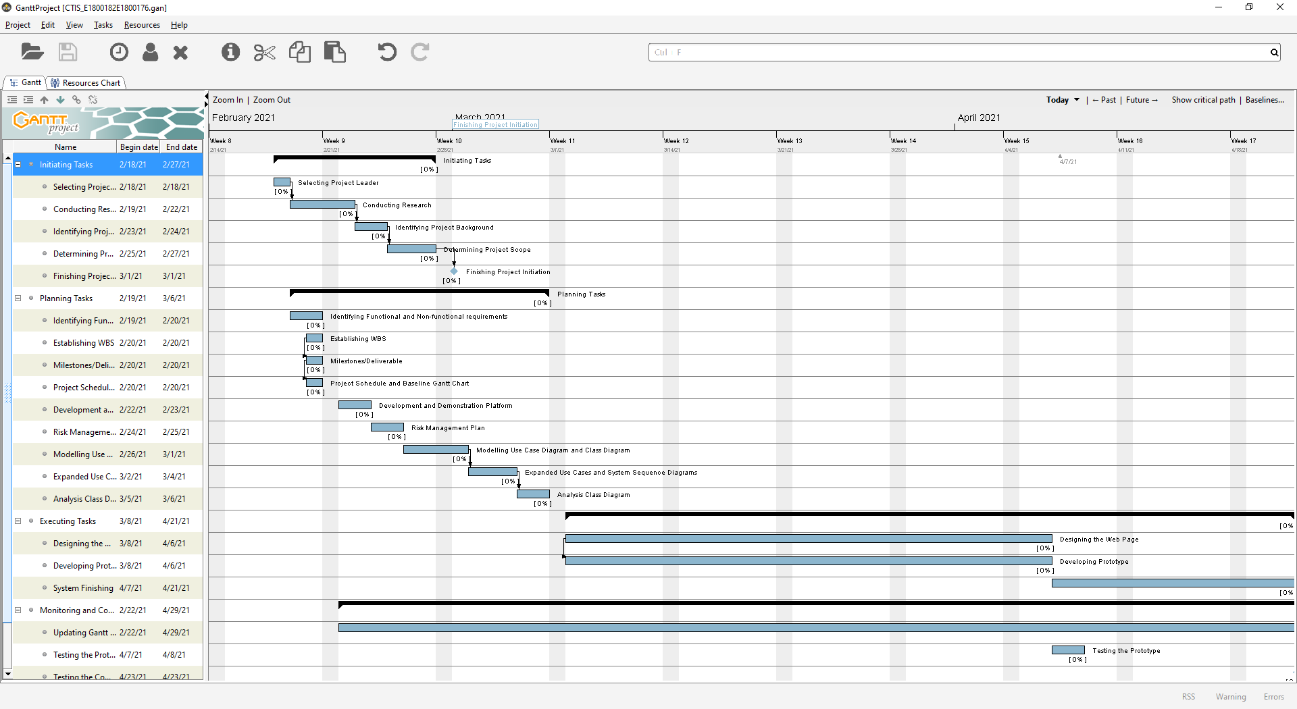

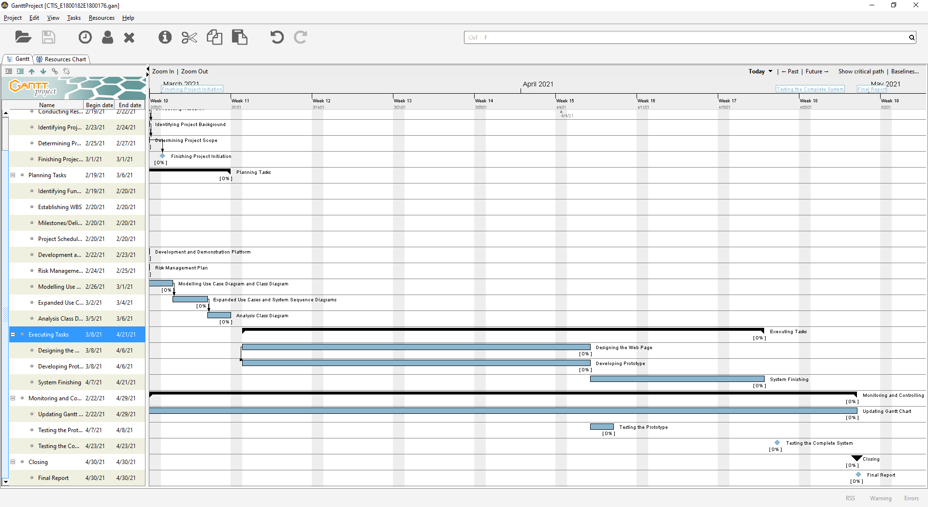

1. **Technical Description**




7. 1. **Development Platform**

**Software/Tools**

1. Microsoft Word

We will use Microsoft Word to create all documents and reports related to the project.

1. Microsoft Visio and Visual Paradigm

We will use Microsoft Visio and Visual Paradigm to create UML model such as use case diagram, class diagram, system sequence diagram, and entity relationship diagram of this project.

1. MySQL

We will use MySQL, a relational database management system based on SQL, because it is open source, reliable, and easy to manage.

1. XAMPP

We will use XAMPP to run a web server and database on the computer localhost for developing and testing purposes of the website. XAMPP will also enable us to

1. PhpStorm

We will use PhpStorm which is a cross-platform IDE for PHP built by the company JetBrains as the tools. We choose to use this IDE because it provides an editor for PHP, HTML, CSS, and JavaScript with auto-completion and error debugging.

1. Adobe Photoshop

We will use Photoshop to edit images that will be used in our website design.

1. GanttProject

We will use GanttProject to create the Gantt chart of our project.

1. Trello

We will use Trello to manage and keep track of the tasks in this project.

1. Git and GitHub

We will use the combination of Git and GitHub to do the version control system of our project. We also use GitHub as the collaboration tool between the project members during the development of the system.

1. Google Chrome

We will use Google Chrome browser for testing purposes of our project. We choose Chrome because it is the most commonly used browser and we only need to do minor adjustment in Chrome in order for the website page to appear nicely in another browser.

**Hardware**

1. Laptop and PC

The development of this system will be done using laptop and PC running Windows operating system.

* 1. **Demonstration Platform**

**Software**

1. Web browser

We choose Google Chrome, Mozilla Firefox, and Microsoft Edge as the demonstration platform for our website because those three are among the most common browsers used now days. We are also considering Microsoft Edge since we are developing the website in PC that run Windows.

**Hardware**

1. Laptop and PC

The website is intended to be opened from a laptop or a PC that have one of the browsers mentioned in software platform installed.

1. Smartphone

Our website is also intended to be opened from a smartphone device browser.

1. **Risk Management Plan**

|  |  |  |  |  |  |  |  |  |  |  |
| --- | --- | --- | --- | --- | --- | --- | --- | --- | --- | --- |
| Risk Management Plan for HELP Covid-19 Testing Information System Website Project | | | | | | | | | | |
| Prepared by: I Made Siva Aditya Surya & Ida Bagus Gede Awidya Andika | | | | | | **Date: 22th February 2021** | | | | |
| NO | Risk Type | Risk | Risk Description | Risk Probab  -ility | Risk Impact | Risk Assessm  -ent Grade | Trigger | Risk Owner | Mitigation Plan | Contingency Plan |
| R1 | Operational Risk | Failure to fully understand all requirements in the project | If requirements are not fully grasped by the project team members, the system that will be delivered may fail to match the user needs and expectations | M | M | 4 | Poorly executed brainstorming of the project requirement and project scope or lack of research conducted on the project | Siva Aditya | Allocate more time to do research and brainstorming, communicate found similar system/event | Conduct a thorough research on the requirements |
| R2 | Schedule Risk | Failure to meet the task deadlines in the project schedule/exceeding working time | Team members are overwhelmed with another assignment/project/event that led to the project to be put aside and left unworked | H | M | 4 | Busy schedule or sudden personal agenda from team members that is unavoidable (accident, family occasion, etc | All | Plan a concrete time schedule for meeting and working on tasks. Com | Allocate more time on the task that is already past the deadline thus it can be finished quickly, and replanning the schedule/deadline of the remaining task |
| R3 | Management Risk | Conflict between project members | Lack of communication/Misunderstanding across project team members may spark conflict or unclear task delegation | H | H | 5 | Busy schedule that results in poor communication between project team members, poorly delivered thoughts and ideas across team members | Siva Aditya | Even in this pandemic time, try to conduct a physical meeting occasionally to avoid miscommunication | Conduct an open discussion meeting to enable each team members to communicate their tasks and ideas more clearly, then resume on working the task based on the final decision of the discussion |
| R4 | Technical Risk | Bugs, crashes, and errors in system | The system may fail to meet the expectation outcome due to logical/integration error | M | H | 4 | Bad coding implementation, not enough testing | Awidya Andika | Do a more thorough checking and conducting testing after every code implementation | Checking the part of system that is causing the error and solve the error by redo the faulty features or implement another method |

Risk Assessment Matrix

|  |  |  |  |  |
| --- | --- | --- | --- | --- |
|  | | Severity of Harm (Impact) | | |
| Low (L) | Medium (M) | High (H) |
| Probability | High (H) | 3 | 4 | 5 |
| Medium (M) | 2 | 3 | 4 |
| Low (L) | 1 | 2 | 3 |

|  |  |
| --- | --- |
| Risk Mitigation Based Upon Grade | |
| Grade | **Possible Action** |
| 5 | Priority risk, mitigation actions are to be identified and implemented at the start of the project |
| 4 | Mitigation actions are to be identified and implemented throughout the course of the project |
| 3 | Mitigation actions are implemented should the time and cost permit execution |
| 2 | Risk to be noted and actions are only required should risk raise in grade over time |
| 1 | Risk to be noted and actions are only required should risk raise in grade over time |

# **Bibliography**

Bonislawski, A. (2020, November 10). *COVID Driving Labs to Build Out Information Systems*. Modern Healthcare. <https://www.modernhealthcare.com/supply-chain/covid-driving-labs-build-out-information-systems>

DoctorOnCall. (2021). *COVID-19 Drive-Thru, Clinic & Home Visit Screening Test Services*. DoctorOnCall. <https://www.doctoroncall.com.my/medicine/coronavirus-covid-19-test-kit>

Lim, K. L., Johari, N. A., Wong, S. T., Khaw, L. T., Tan, B. K., Chan, K. K., Wong, S. F., Chan, W. L. E., Ramzi, N. H., & Lim, P. K. C. (2020). A novel strategy for community screening of SARS-CoV-2 (COVID-19): Sample pooling method. *PLoS ONE*, *15*(8), e0238417. <https://doi.org/10.1371/journal.pone.0238417>

Malaysia MOH. (2021, February 24). *Situasi Terkini COVID-19 di Malaysia 23 Februari 2021*. COVID-19 MOH Malaysia. <http://covid-19.moh.gov.my/terkini/2021/feb/situasi-terkini-covid-19-di-malaysia-23022021>

Sommerville, I. (2016). *Software engineering 10th Edition*. Pearson Education.

Wikipedia. (2021, February 24). *Coronavirus disease 2019*. Wikipedia, The Free Encyclopedia.

WHO. (2021, February 24). *WHO Coronavirus Disease (COVID-19) Dashboard*. WHO (COVID-19) Homepage. <https://covid19.who.int/>